**2B Examination, 2011**

**Question/Answer Booklet**

ECONOMICS

**Stage 2**

|  |  |  |  |  |  |  |  |  |  |  |
| --- | --- | --- | --- | --- | --- | --- | --- | --- | --- | --- |
| Student Number: In figures |  |  |  |  |  |  |  |  |  |  |

In words

#### Time allowed for this paper

Reading time before commencing work: ten minutes

Working time for paper: two and a half hours

**Materials required/recommended for this paper**

To be provided by the supervisor

This Question/Answer Booklet

Multiple-choice Answer Sheet

***To be provided by the candidate***

Standard items: pens, pencils, eraser, correction fluid, ruler, highlighters

Special items:non-programmable calculators satisfying the conditions set by the Curriculum Council for this course.

**Important note to candidates**

No other items may be taken into the examination room. It is your responsibility to ensure that you do not have any unauthorised notes or other items of a non‑personal nature in the examination room. If you have any unauthorised material with you, hand it to the supervisor before reading any further.

**Structure of this paper**

|  |  |  |  |  |  |
| --- | --- | --- | --- | --- | --- |
| Section | Number of questions available | Number of questions to be answered | Suggested working time (minutes) | Marks available | Percentage of exam |
| Section One: Multiple-choice | 20 | 20 | 25 | 20 | 23% |
| Section Two: Data interpretation/ Short response | 4 | 4 | 85 | 48 | 54% |
| Section Three: Extended response | 2 | 1 | 40 | 20 | 23% |
|  |  |  | **Total** | **88** | 100% |

**Instructions to candidates**

1. The rules for the conduct of Western Australian external examinations are detailed in the *Year 12 Information Handbook 2011.* Sitting this examination implies that you agree to abide by these rules.

2. Answer the questions according to the following instructions.

Section One: Answer all questions on the separate Multiple-choice Answer Sheet provided. For each question shade the box to indicate your answer. Use only a blue or black pen to shade the boxes. If you make a mistake, place a cross through that square, do not erase or use correction fluid, and shade your new answer. Marks will not be deducted for incorrect answers. No marks will be given if more than one answer is completed for any question.

Section Two: Write answers in this Question/Answer booklet. Spare pages are included at the end of the booklet. They can be used as additional space if required to continue an answer. IF you need to use the space to continue an answer, indicate in the original answer space where the answer is continued, i.e. give the page number. Fill in the number of the question(s) you are continuing at the top of the page.

Section Three: Write answers in this Question/Answer booklet. Pages are included at the end of this booklet for planning and writing your answer.

* Planning: If you use the spare pages for planning, indicate this clearly at the top of the page.
* Answering the question: In the pages provided indicate clearly the number of the question you are answering.

3. You must be careful to confine your responses to the specific questions asked and to follow any instructions that are specific to a particular question.

**Section One: Multiple-choice 23% (20 Marks)**

This section has **20** questions. Answer **all** questions on the separate Multiple-choice Answer Sheet provided. For each question shade the box to indicate your answer. Use only a blue or black pen to shade the boxes. If you make a mistake, place a cross through that square, do not erase or use correction fluid, and shade your new answer. Marks will not be deducted for incorrect answers. No marks will be given if more than one answer is completed for any question.

Suggested working time for this section is 25 minutes.

______________________________________________________________________________

1. Macroeconomics includes the study of

(a) total spending and inflationary trends but not employment and unemployment.

(b) individual markets and their impact on the level of economic activity.

(c) the economy as a whole ignoring short term fluctuations.

(d) all aggregates within the economy and the relationship between them.

2. The general level of economic activity in Australia basically depends on the

(a) level of consumer spending.

(b) government budget outcome.

(c) level of household disposable income.

(d) level of aggregate expenditure.

3. Assume that an economy is in equilibrium. Savings total $60b, government expenditure is $80b, investment is $80b and taxation is $70b. The value of net exports is

(a) - $30b

(b) +$30b

(c) -$130b

(d) -$10b

4. The investment demand curve is likely to shift to the left if

(a) consumer demand increases.

(b) the interest rate increases.

(c) expected returns on investment increase.

(d) business taxes increase.

5. Which of the following would most likely decrease as a result of an upturn in the business cycle? The

(a**)** rate of inflation

(b) level of economic activity

(c)level of imports

(d) rate of unemployment

6. If a person buys a pizza from a restaurant rather than making the same product at home

(a) GDP increases

(b) GDP decreases

(c) GDP remains unchanged

(d) society's well-being increases

7. If a nation’s resources are fully and efficiently employed, economic growth can be represented by

(a) a movement along its production possibility curve.

(b) a movement towards its production possibility curve.

(c) an inward shift of its production possibility curve.

(d) outward shift of if production possibility curve.

8. If real GDP rises, it is still possible for living standards in the country to fall if

(a) there is an improvement in the quality of goods produced.

(b) the population rises faster than the growth of real GDP.

(c) the government increases taxes to make the distribution of income more equal.

(d) there are more non-marketed goods and services.

9. One of the costs of economic growth is

(a) inflationary pressures.

(b) rising levels of unemployment.

(c) increasing aggregate demand.

(d) lower living standards.

10. Suppose that the number of jobs in the logging industry decreases but the number of jobs in the tourism industry increases. Initially,

(a) the economy remains at full employment.

(b) there is a shortage of workers in both sectors.

(c) cyclical unemployment increases.

(d) structural unemployment increases.

11. If the present rate of unemployment is equal to the natural rate, which of the following must equal zero?

(a) Frictional unemployment

(b) Seasonal unemployment

(c) Structural unemployment

(d) Cyclical unemployment

12. To an economy, the opportunity cost of unemployment is the

(a) loss in Gross Domestic Product.

(b) value of unemployment benefits.

(c) loss of taxation revenue.

(d) cost of retraining schemes.

13. In a market economy, a private producer is unlikely to provide street lighting because

(a) there would be little demand for street lighting.

(b) it would be too costly to produce such a service.

(c) not all consumers could afford to pay for such a service.

(d) it would be difficult to exclude non-payers from enjoying the benefits of the service.

14. When the actual rate of inflation exceeds anticipated inflation

(a) borrowers gain at the expense of lenders.

(b) borrowers and lenders both lose.

(c) borrowers and lenders both gain.

(d) lenders gain at the expense of borrowers.

15. What is the rate of inflation if the CPI was 110 in Year 1 and 120 in Year 2?

(a) 10%

(b) 10.1%

(c) 9.0%

(d) 9.1%

16. The underlying rate of inflation is seen by economists as more significant than the headline rate because it

(a) includes more goods and services in its regimen.

(b) includes those items on which households spend most of their income.

(c) excludes those items whose prices rise and fall frequently.

(d) is revised more regularly to reflect changes in consumer spending patterns.

17. In what sense is the Australian current account deficit beneficial to the Australian economy?

(a) It makes total Australian domestic saving, private and government, larger.

(b) Because Australia must reduce consumption to repay the debt to foreigners.

(c) If the current account deficit is large, the government budget deficit must be small.

(d) It is associated with borrowing from foreigners, which helps finance Australian investment.

18. As a percentage of Gross Domestic Product which one of the following is a measure of external stability?

(a) The budget deficit

(b) The current account deficit

(c) The trade balance

(d) Net income

19. Which of the following would be recorded as a debit item in the Capital and Financial Account of Australia’s Balance of Payments?

(a) Interest repayments by Australian firms on overseas loans.

(b) Australian borrowing from Japanese banks.

(c) Dividends received by Australian shareholders on overseas investments.

(d) Australian firms expanding by building new plants in China.

20. The table below shows selected data for an economy that uses a floating exchange rate.

|  |  |
| --- | --- |
| **Balance of payments item** | **$bn** |
| Exports of goods | 180 |
| Import of goods | 205 |
| Net services | 10 |
| Net income | -50 |
| Net current transfers | -5 |
| Balance on capital account | 2 |
| Balance on financial account | 68 |

For this economy the balance on goods and services is

(a) –$15bn and the balance on current account is –$70bn.

(b) –$35bn and the balance on current account is –$70bn.

(c) $15bn and the balance on current account is $30bn.

(d) $35bn and the balance on current account is $90bn.

**End of Section One**

**Section Two: Data interpretation/Short response 54% (48 Marks)**

This section has **four (4)** questions. Answer **all** questions. Write your answers in the space provided.

Spare pages are included at the end of this booklet. They can be used as additional space if required to continue an answer. If you need to use the space to continue an answer, indicate in the original answer space where the answer is continued, i.e. give the page number. Fill in the number of the question(s) that you are continuing to answer at the top of the page.

Suggested working time for this section is 85 minutes.

**Question 21 (12 marks)**

This question refers to the graph below.

1

4

2

3

(a) (i) Label the axes of the graph. (1 mark)

(ii) Identify the phases of the business cycle labelled 1 – 4. (2 marks)

1. ______________________ 2. ______________________

3. ______________________ 4. ______________________

(b) Identify one: (3 marks)

(i) Leading indicator of economic activity. __________________________________

(ii) Coincident indicator of economic activity. __________________________________

(iii) Lagging indicator of economic activity. __________________________________

(c) Briefly outline 2 ways that economic policy can be used to stabilise the recession phase of the business cycle. (2 marks)

____________________________________________________________________________________________________________________________________________________________________________________________________________________________________________________________________________________________________________________________________________________________________________________________________________________________________________________________________________________

(d) Explain the main characteristics of therecession phase of the business cycle. (4 marks)

__________________________________________________________________________________________________________________________________________________________________________________________________________________________________________________________________________________________________________________________________________________________________________________________________________________________________________________________________________________________________________________________________________________________________________________________________________________________________________________________________________________________________________________________________________________________________________________________________________________________________________________________________________________________________________________________________________________________________________________________________________________________________________________________________________________________________________________________________________________________________________________________________________________

**Question 22 (12 marks)**

This question refers to the extract below.

**The Australian labour market and the global financial crisis**

Unlike most advanced economies, the Australian labour market was remarkably resilient during the GFC and, following a short period of weakness, has since strengthened. Over the past 18 months, employment has grown strongly, the unemployment rate has fallen steadily, and the participation rate has reached record highs. The long‑term unemployment rate remains low and continues to decline.

In the lead up to and during the GFC, the unemployment rate rose by a total of around 1¾ percentage points (from 4.0 to 5.8 per cent) in Australia, compared with around a 2¾ percentage point rise in Canada, a 3½ percentage point rise in New Zealand and a 5¾ percentage point rise in the United States. Not only was the increase in Australia's unemployment rate relatively modest, but the subsequent recovery has been substantial, with the unemployment rate falling to 4.9 per cent as at March 2011, lower than all the major advanced economies except Japan. Australia's record on unemployment during the GFC is all the more impressive in the context of the increase in labour force participation that has occurred over this period.

After a short decline during the downturn, Australia's participation rate rebounded strongly, reaching a record high of 66.0 per cent in November 2010. Since March 2007, Australia's participation rate has increased around ¾ of a percentage point, compared with no change in New Zealand, a ½ of a percentage point decrease in Canada and a 2 percentage point decrease in the United States.

In Australia, this reflects the return of previously discouraged job seekers, as well as a trend increase in the participation of females and older workers. The participation rate of those aged 55+ has increased by around 4 percentage points since March 2007. Source Budget paper Number 1 2011

(a) Define the following terms used in the extract: (3 marks)

(i) Unemployment rate

___________________________________________________________________

(ii) Long term unemployment

___________________________________________________________________

(iii) Discouraged worker

___________________________________________________________________

(b) Which type of unemployment would have risen during the global financial crisis? Explain your answer. (2 marks)

________________________________________________________________________________________________________________________________________________________________________________________________________________________________________________________________________________________

(c) Explain why the fall in the unemployment rate is impressive in the light of the rise in the participation rate. (3 marks)

______________________________________________________________________________________________________________________________________________________________________________________________________________________________________________________________________________________________________________________________________________________________________________________________________________________________________________________________________________________________________________________________________________________________________________________________________________________________________________________

(d) Discuss 2 reasons for Australia’s strong employment performance during and after the Global Financial Crisis. (4 marks)

__________________________________________________________________________________________________________________________________________________________________________________________________________________________________________________________________________________________________________________________________________________________________________________________________________________________________________________________________________________________________________________________________________________________________________________________________________________________________________________________________________________________________________________________________________________________________________________________________________________________________________________________________________________________________________________________________________________________________________________________________________________________________________________________________________________________

**Question 23 (12 marks)**

This question refers to the information below.

**Household consumption**

Household consumption growth has moderated since the onset of the GFC. While the

labour market has strengthened, household incomes have grown solidly and consumer

confidence is around its long-term average, consumers continue to be cautious. Source: Budget Paper Number 1 2011

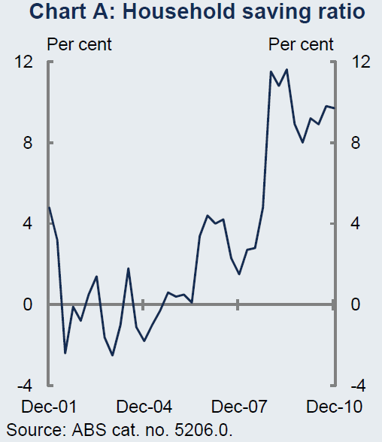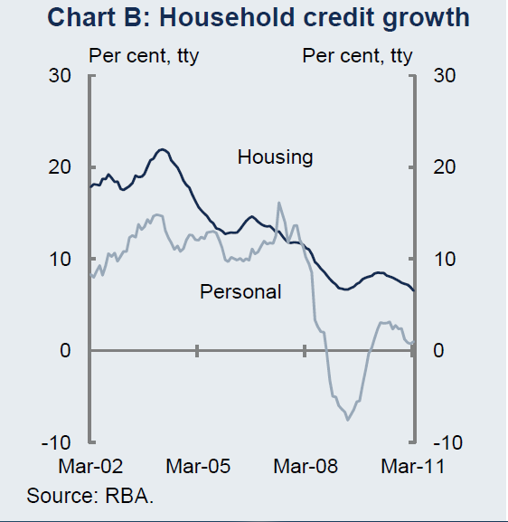

Complete the following: (4 marks)

(a) (i) In December 2010, household savings was approximately __________ of income and consumption was _________ of income, whereas in December 2004 household savings was approximately __________ of income and household consumption was _________ of income.

(ii) When household savings are negative this means that their consumption is

__________________________________________________________________ .

(iii) When household credit growth is negative this means that households are

___________________________________________________________________.

(b) Approximately what percentage of aggregate expenditure does household consumption represent? (1 mark)

____________________

(c) Apart from housing which type of spending do households usually finance with credit?

____________________ (1 mark)

(d) Discuss the factors that could have influenced households to spend less and save more over recent years. (6 marks)

____________________________________________________________________________________________________________________________________________________________________________________________________________________________________________________________________________________________________________________________________________________________________________________________________________________________________________________________________________________________________________________________________________________________________________________________________________________________________________________________________________________________________________________________________________________________________________________________________________________________________________________________________________________________________________________________________________________________________________________________________________________________________________________________________________________________________________________________________________________________________________________________________________________________________________________________________________________________________________________

**Question 24 (12 marks)**

This question refers to the table below

**Marginal personal income tax rates 2010–2011**

|  |  |  |  |
| --- | --- | --- | --- |
| **Taxable Income $ p.a.** | **Tax on Income $ p.a.** |  | **Tax on excess above lower threshold (marginal tax rate) %** |
| Nil to 6000 | 0 | plus | 0 |
| 6001 to 37 000 | 0 | plus | 15 |
| 37 001 to 80 000 | 4650 | plus | 30 |
| 80 001 to 180 000 | 17 550 | plus | 37 |
| 180 001 plus | 54 550 | plus | 45 |

Source: Parliamentary Library estimates

(a) Define the following terms: (2 marks)

(i) Tax threshold

___________________________________________________________________

(ii) Marginal tax rate

___________________________________________________________________

(b) (i) Is personal income tax a direct or indirect tax? Explain your answer. (2 marks)

___________________________________________________________________

___________________________________________________________________

(ii) Use the table below to identify any two (2) other taxes that the Commonwealth Government imposes and classify them as direct/indirect and proportional/progressive/regressive. (2 marks)

|  |  |  |
| --- | --- | --- |
| Tax name | Direct/Indirect | Proportional/Progressive/Regressive |
|  |  |  |
|  |  |  |

(c) Is the personal income tax system progressive, regressive or proportional? Use data from the table to explain your answer. (3 marks)

______________________________________________________________________________________________________________________________________________________________________________________________________________________________________________________________________________________________________________________________________________________________

(d) Explain why the Commonwealth government uses this type of personal income tax system. Use a Lorenz curve to illustrate your answer. (3 marks)

Lorenz curve

____________________________________________________________________________________________________________________________________________________________________________________________________________________________________________________________________________________________________________________________________________________________________________________________________________________________________________________________________________________________________________________________________________________________________________________________________________________________________________________________________________________________________________

**Section Three: Extended response 23% (20 Marks)**

This section contains **two (2)** questions. You must answer **one (1)** question. Write your answers in the space provided and number your answers clearly.

Pages are included at the end of this booklet for planning and writing your answer.

* + Planning: If you use the spare pages for planning, indicate this clearly at the top of the page.
  + Answering the question: In the pages provided indicate clearly the question number you are answering.

Suggested working time for this section is 40 minutes.

**Question 25 (20 marks)**

(a) Using a diagram, explain the concept of equilibrium in the five sector circular flow of income model of the Australian economy. (10 marks)

(b) Explain how the economy will return to equilibrium following an increase in planned investment. (10 marks)

**Question 26 (20 marks)**

(a) Explain how the Australian Bureau of Statistics calculates the Consumer Price Index (CPI). (6 marks)

(b) Discuss the causes and effects of inflation with reference to the Australian economy. (14 marks)

**End of questions**